*FOREIGN TRADE UNIVERSITY*

**HO CHI MINH CITY CAMPUS**

---------***---------



**MID-COURSE INTERNSHIP REPORT**

**Major: International Finance**

**QUANTITATIVE ALPHA DEVELOPMENT FOR VN30F1M FUTURE CONTRACT AT HEPHAESTUS TECHNOLOGY JSC**

**Student: Tran Trung Chien**

**Student ID: 2112343020**

**Class: K60CLC3**

**Intake: K60**

**Supervisor: Dr. Le Tuan Bach**

**Ho Chi Minh City, August 2024**

*FOREIGN TRADE UNIVERSITY*

**HO CHI MINH CITY CAMPUS**

---------***---------

**MID-COURSE INTERNSHIP REPORT**

**Major: International Finance**

**QUANTITATIVE ALPHA DEVELOPMENT FOR VN30F1M FUTURE CONTRACT AT HEPHAESTUS TECHNOLOGY JSC**

**Student: Tran Trung Chien**

**Student ID: 2112343020**

**Class: K60CLC3**

**Intake: K60**

**Supervisor: Dr. Le Tuan Bach**

**Ho Chi Minh City, August 2024**

|  |  |
| --- | --- |
| FOREIGN TRADE UNIVERSITY  **HO CHI MINH CITY CAMPUS** | **SOCIALIST REPUBLIC OF VIETNAM**  **Independence - Freedom - Happiness** |

**MIDTERM PROFESSIONAL REPORT REMARKS**

Student’s full name:

Student code:

Name of the report:

**Remarks**:

**Assessment of compliance with regulations, progress and work ethics** (Maximum of 1.0 point, with one decimal number):

*Ho Chi Minh City, ….../….../...............*

**Supervisor**

*(Signature with full name)*

***Note:*** This evaluation remark is enclosed with the report, right after the cover page. The student must give this form to the supervisor for comments and scoring of his/her morale, attitude, and diligence and submit the report in accordance with the relevant notice.

**INTERNSHIP ORGANIZATION’S REMARKS**

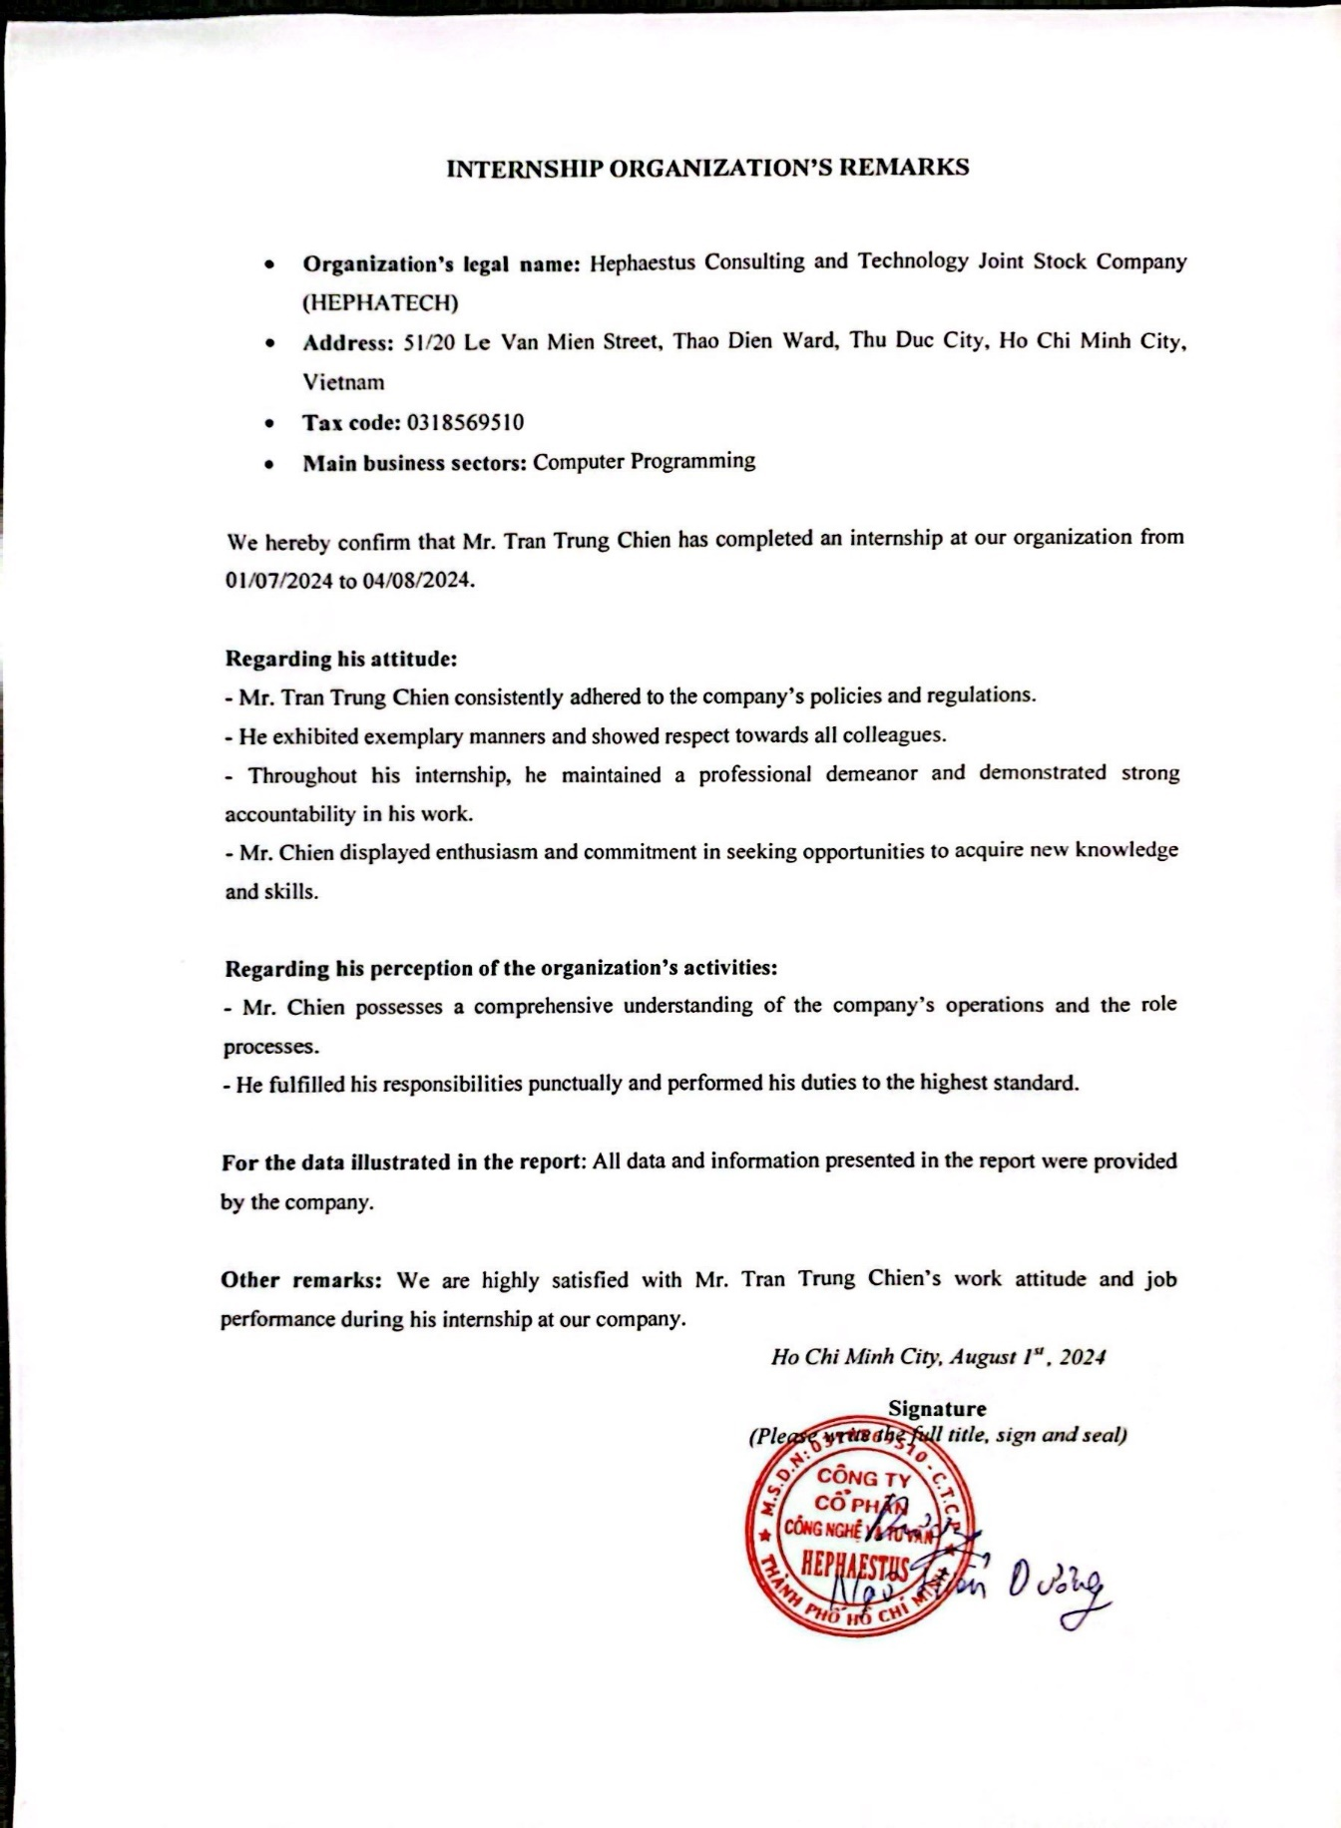

**DECLARATION**

I affirm that I have authored the mid-course internship report titled “**Quantitative Alpha Development for VN30F1M Future Contract at Hephaestus Technology JSC**” with the supervision of Dr. Le Tuan Bach. This report has not been presented to any other university or institution to obtain a degree or diploma.

I have properly recognized all the sources of information utilized in writing this report.

I also attest that I have followed the guidelines of Foreign Trade University and upheld the utmost integrity and academic honesty in carrying out this report.

|  |  |
| --- | --- |
|  | *Ho Chi Minh City, August 2024*  **Author**  **Tran Trung Chien** |

**ACKNOWLEDGMENT**

I am deeply grateful for the incredible learning opportunity provided during my internship as a Quantitative Research Intern at Hephaestus Consulting and Technology JSC (HEPHATECH). This experience has profoundly enriched my professional knowledge and offered practical insights that will be invaluable in my future career.

I would like to express my heartfelt thanks to Ms. Nguyen Thi Tuong Vy, the Talent Acquisition Manager at HEPHATECH, for presenting me with this exceptional internship opportunity. My sincere gratitude also goes to my mentor, Mr. Ngo Hien Duong, the Head of the Quantitative Research Department at HEPHATECH, whose unwavering support, insightful guidance, and dedicated advice were crucial to the successful completion of this report. I am also thankful to all the members of the Quantitative Research Department for their enthusiastic support and for fostering a conducive learning environment.

While compiling this report, I have tried to meticulously collect information, formulate ideas, and structure the content. Even though I worked hard, I acknowledge that achieving perfection is difficult, and there may have been some errors. Hence, I am very thankful to Dr. Le Tuan Bach, my supervisor, for his ongoing assistance and precise input, which significantly improved the caliber of my report. I hope for his success and look forward to working together in the future.

Finally, I would like to express my utmost gratitude to the committed teachers at Foreign Trade University - Ho Chi Minh City Campus. Their dedication to teaching and strong commitment to providing top-notch education have given me a solid base of professional knowledge during the last three years.

I am genuinely grateful to all those who have helped make this internship experience valuable and fulfilling.

**TABLE OF CONTENTS**

PREFACE 1

CHAPTER 1: INTRODUCTION TO HEPHAESTUS CONSULTING AND TECHNOLOGY JOINT STOCK COMPANY (HEPHATECH) 3

1.1 Company overview 3

1.1.1 General information about Hephaestus Consulting and Technology Joint Stock Company (HEPHATECH) 3

1.1.2 Organizational structure 4

1.1.3 Business Operations 5

1.1.4 Business Performance 6

1.1.5 Brief description of the internship period at HEPHATECH 7

CHAPTER 2: ALPHA DEVELOPMENT FOR VN30F1M AT HEPHATECH 9

2.1 Analysis of futures’ alpha development process 9

2.1.1 Standardized process 9

2.1.2 Standardized process versus theoretical process 10

2.2 Practical description for VN30F1M’s alpha development at HEPHATECH 11

2.2.1 Data preparation 11

2.1.2 Exploratory Data Analysis 12

2.1.3 Alpha Development 12

2.1.4 Backtesting on IS data 14

2.1.5 Optimization 16

2.1.6 Backtesting on OS data 17

2.1.7 Paper Trading 18

2.1.8 Alpha Deployment 18

2.2 The standardized process versus practical implementation 19

2.3 General assessment on the alpha development process at HEPHATECH 20

2.3.1 Strength 20

2.3.2 Weaknesses 21

CHAPTER 3: SELF-REFLECTION OF THE INTERNSHIP AT HEPHATECH 22

3.1 Personal experience 22

3.2 Recommendations for the Internship Unit 23

CONCLUSION 26

REFERENCE 27

APPENDIX 29

**LIST OF ABBREVIATIONS**

|  |  |
| --- | --- |
| AI | Artificial Intelligence |
| API | Application Programming Interface |
| AWS | Amazon Web Services |
| EDA | Exploratory Data Analysis |
| ETF | Exchange-Traded Fund |
| HEPHATECH | Hephaestus Consulting and Technology Joint Stock Company |
| HOSE | Ho Chi Minh Stock Exchange |
| HSI | Hang Seng Index |
| IoT | Internet of Things |
| IS | In-Sample |
| JSC | Joint Stock Company |
| OHLCV | Open, High, Low, Close, Volume |
| OS | Out-of-Sample |
| PnL | Profit and Loss |
| R&D | Research & Development |
| S3 | Simple Storage Service |
| SPX | S&P 500 Index |
| SQL | Structured Query Language |
| VN30F1M | VN30 Index Futures 01 month |

**LIST OF FIGURES**

Figure 1.1. Organizational structure of HEPHATECH. Source: Self-compiled. 4

Figure 2.1. The standardized process of alpha development for futures trading at HEPHATECH. Source: Self-compiled from internal training at HEPHATECH. 9

Figure 2.2. Position’s generation. Source: Self-coding output. 14

Figure 2.3. Vectorized backtesting result. Source: Self-coding output. 15

Figure 2.4. IS backtesting results. Source: Self-coding output. 16

Figure 2.5. OS backtesting results. Source: Self-coding output. 17

**LIST OF TABLES**

Table 1.1. Company overview. Source: Self-compiled. 4

Table 1.2. Business performance of HEPHATECH during the last 12 months. Source: Internal report. 7

Table 2.1. Comparison of the standardized process and practical implementation for developing alphas in future contracts at HEPHATECH. 20

# 

# PREFACE

The futures market is a dynamic and complex arena where financial instruments are traded to hedge risks or speculate on future price movements. Among these, VN30F1M represent a significant segment within the Vietnamese financial market, offering opportunities for strategic trading and investment. This report, titled “Quantitative Alpha Development for VN30F1M Future Contract at Hephaestus Technology JSC”, explores the development of quantitative strategies aimed at generating alpha, or excess returns, in this market.

The VN30F1M future contract, as a key financial instrument, is influenced by a range of factors including market trends, economic indicators, and geopolitical events. Accurately predicting movements in these futures requires sophisticated analytical approaches. Traditional methods often fall short in capturing the nuances of the market, which has driven the need for advanced quantitative techniques. By leveraging mathematical and statistical models, and harnessing the power of algorithms and machine learning, quantitative analysis can provide valuable insights and enhance decision-making processes.

During my internship at HEPHATECH, I engaged deeply with the development and implementation of quantitative strategies for VN30F1M. My work involved using Python for alpha development, backtesting IS and OS data and implementing paper trading strategies. Additionally, I utilized AWS for storing paper trading records, employing Lambda functions to manage data storage in S3 buckets. The use of PostgreSQL for data management to query the company’s trading data and Linux/Ubuntu to set cron jobs ensured a robust and efficient development environment.

This report aims to document my experience and insights gained throughout the internship. It is structured as follows:

**Chapter 1: Introduction to Hephaestus Consulting and Technology Joint Stock Company (HEPHATECH)**

This chapter provides an overview of HEPHATECH, where I completed my internship as a Quantitative Researcher. It includes a description of the company’s background, its mission, and its role within the financial industry. Special emphasis is given to the company’s expertise in trading VN30F1M and its application of quantitative methods.

**Chapter 2: Alpha Development for VN30F1M at HEPHATECH**

Chapter 2 delves into the core of the report, focusing on the methodologies and techniques used for alpha development for VN30F1M. It covers the analytical tools and technologies employed by the research team, including Python for alpha development, backtesting, and paper trading implementation. PostgreSQL for data management, and AWS for computational tasks. The chapter also details the use of AWS for storing paper trading records via Lambda functions to S3, PostgreSQL for data management, and Linux/Ubuntu for setting cron jobs. Specific projects and case studies will be presented to illustrate the effectiveness of these strategies in supporting trading decisions.

**Chapter 3: Self-Reflections on the Internship Experience**

The final chapter reflects on my personal journey during the internship. It offers insights into the challenges faced, skills acquired, and achievements realized as a Quantitative Researcher. Additionally, it provides an assessment of how the internship has contributed to my professional growth and future career aspirations.

I extend my deepest gratitude to the entire team at HEPHATECH for their guidance and support throughout my internship. Their expertise and mentorship have been pivotal in enhancing my comprehension of quantitative finance and its real-world uses.

.

# CHAPTER 1: INTRODUCTION TO HEPHAESTUS CONSULTING AND TECHNOLOGY JOINT STOCK COMPANY (HEPHATECH)

## 1.1 Company overview

### 1.1.1 General information about Hephaestus Consulting and Technology Joint Stock Company (HEPHATECH)

Hephaestus Consulting and Technology Joint Stock Company (HEPHATECH) embodies the essence of the Greek god Hephaestus, known for his remarkable skills in technology and craftsmanship. In the same way that Hephaestus was praised for his inventive designs, HEPHATECH is leading the way in software and AI advancements, dedicated to accuracy and quality.

Established in 2023, the organization utilizes advanced algorithms and machine learning models to create complex systems that can learn and adapt autonomously. Its technological solutions cover various applications such as natural language processing, automated financial trading, data analysis, and predictive modeling. This shows a commitment to creating groundbreaking solutions that offer substantial benefits in different areas.

The teams at HEPHATECH consists of seasoned software developers, AI researchers, and experts from various fields. Their collective knowledge enables the successful addressing of intricate obstacles and creation of strategies that improve operational effectiveness and promote strategic expansion.

Taking inspiration from Hephaestus's renowned skill, HEPHATECH utilizes strict scientific and engineering methods to develop advanced and beneficial technological solutions. The goal is to consistently challenge limits of innovation, providing customized solutions for the changing demands of today's business world.

HEPHATECH continues the tradition of Hephaestus by paving the way for excellence and innovation, guaranteeing that customers receive top-notch technological advancements and operational efficiency.

|  |  |  |
| --- | --- | --- |
|  | Legal name | Hephaestus Consulting and Technology Joint Stock Company (HEPHATECH) |
| Headquarters: | 51/20 Le Van Mien Street, Thao Dien Ward, Thu Duc City, Ho Chi Minh City, Vietnam |
| Phone number: | 0867167397 |
| Website: | https://hephtechnologies.com/  https://quantitative-trading.net/ |
| Tax Code: | 0318569510 |
| Registered capital | 200.000.000 VND |

Table 1.1. Company overview. Source: Self-compiled.

### 1.1.2 Organizational structure

HEPHATECH is a dynamic startup specializing in advanced technologies and innovative research to succeed in financial markets. The company operates within a collaborative framework, consisting of four key teams, each with specific roles and responsibilities.

Figure 1.1. Organizational structure of HEPHATECH. Source: Self-compiled.

The **AI Research Team** at HEPHATECH drives innovation by developing and integrating advanced AI and machine learning algorithms to analyze complex data and create predictive models. The **Quantitative Research Team** refines trading strategies using mathematical and statistical techniques, performing backtesting to optimize performance. The **Development Team** oversees technology infrastructure, ensuring robust and efficient systems for research and trading. The **Marketing Team** enhances brand visibility, manages client relationships, and executes targeted campaigns to attract and retain clients.

The Quantitative Research department, where I interned, is central to this report. This department leverages quantitative analysis to develop and refine trading strategies. During my internship, I collaborated with experienced researchers to build, backtest, and simulate trading models, transitioning from paper trading to real-time trading.

### 1.1.3 Business Operations

HEPHATECH focuses on international collaboration, technological innovation, and educational outreach in AI and Data Science. The company’s core business is computer programming, which underpins its project development, quantitative trading, and educational initiatives. HEPHATECH's expertise in programming enables the development of complex algorithms, robust software applications, and advanced quantitative trading platforms, driving success in AI, data science, and fintech.

1. **International Partnerships and Project Development**

HEPHATECH's business operations heavily focus on working with global partners to progress projects in AI and data science. These collaborations enable the company to utilize international knowledge, exchange resources, and attain cutting-edge technologies. HEPHATECH collaborates with global partners to participate in impactful AI and data analytics projects, improving its tech skills and growing its market reach.

1. **Development of Python Quantitative Trading libraries**

HEPHATECH creates helpful quantitative trading libraries for financial professionals and institutions. These libraries combine sophisticated programming, quantitative analysis, and algorithmic trading strategies, providing essential resources for developing and executing trading algorithms. By offering comprehensive and adaptable libraries, HEPHATECH enhances clients' trading strategies, decision-making, and performance in financial markets, showcasing the company's commitment to innovation and top-notch technological solutions.

1. **Algorithmic Trading Education: ICLS Tech**

HEPHATECH also offers algorithmic trading education through ICLS Tech, a section dedicated to enhancing skills in data analysis, fintech, and machine learning/AI. Established by Vietnamese and international professionals, ICLS Tech has over 13 years of experience. It aims to connect Vietnamese expertise with global standards, promoting international competitiveness.

### 1.1.4 Business Performance

During the latter part of 2023, Hephaestus Consulting and Technology Joint Stock Company (HEPHATECH) faced a difficult time. Total revenue was 253 million VND, whereas total costs were notably higher at 496 million VND. This led to a total deficit of 243 million VND. The difference in sales and expenses shows the early challenges and investments in building the company's infrastructure and market presence. This period marked a phase of significant investment in R&D, marketing, and the establishment of technological foundations, which were essential for the company’s long-term growth but resulted in short-term financial strain.

In late 2023, the global economic slowdown impacted many technology firms, including HEPHATECH, as investments in tech sectors saw a temporary decline. This pressure contributed to the company’s initial financial struggles, despite significant internal investment in infrastructure and technology. However, new governmental incentives for technology innovation and startups provided a more supportive environment for tech companies, which mitigated some of the financial challenges faced by HEPHATECH. These policies included tax reliefs, grants for R&D, and subsidies for technology adoption, which eased the financial burden on the company during its initial phase of heavy investment.

|  |  |  |  |  |  |
| --- | --- | --- | --- | --- | --- |
|  |  | **Unit: million Viet Nam Dong (VND)** | | |  |
|  | **June – Dec 2023** | | **Jan – June 2024** | **% Change** | |
| **Total Revenue** | **253** | | **537** | **112.25%** | |
| **Total Expenses** | **496** | | **182** | **-63.31%** | |
| **Net Income** | **-243** | | **355** | **246.09%** | |

Table 1.2. Business performance of HEPHATECH during the last 12 months. Source: Internal report.

The first half of 2024 marked a substantial turnaround for HEPHATECH. Total sales saw a significant increase to 537 million VND, reflecting the company’s improved market penetration and the effectiveness of its strategic initiatives. Total expenses were reduced to 182 million VND, indicating more efficient operational management and cost-control measures. This resulted in a net profit of 355 million VND, showcasing the company's ability to leverage its investments and strategic adjustments to achieve profitability.

In early 2024, economic recovery boosted HEPHATECH's performance. Increased consumer spending and renewed investor confidence in tech sectors improved sales and long-term contract opportunities. The global shift towards digital transformation, especially in AI and IoT, heightened demand for HEPHATECH’s automation and data analytics solutions. Additionally, the local currency's depreciation enhanced export competitiveness, further driving sales and profitability. These factors combined to stabilize and propel HEPHATECH into a profitable trajectory, leveraging both domestic support and international trends.

### 1.1.5 Brief description of the internship period at HEPHATECH

During my 1-month internship at HEPHATECH, I worked as a Quantitative Research Intern, engaging in financial data analysis, trading strategy development, and alpha deployment. Under the guidance of the Head of Research and experienced professionals, I gained practical experience and insights into financial markets, benefiting from a supportive and collaborative team environment.

**Preparation Phase (1st week)**

During my first week at HEPHATECH, I focused on building a solid foundation for my internship tasks. This involved:

* Reviewing historical VN30F1M data and exploring the data infrastructure.
* Studying the company's alpha development and standardization processes.
* Attending meetings to clarify expectations, set goals, and outline tasks for the upcoming phases.

**Active Internship Phase (2nd and 3rd weeks)**

During the second week of my internship, I concentrated on data preparation and EDA. I collected and cleaned VN30F1M historical data, ensuring its accuracy, and performed thorough data analysis to identify patterns and insights for feature selection.

In the third week, I focused on alpha development and validation. I developed and tested various predictive models using statistical and machine learning techniques, conducted backtesting on both in-sample and out-of-sample data, optimized the models, and simulated trading conditions with paper trading. Finally, I prepared the alpha models for integration into the company's live trading systems.

**Conclusion Phase (4th week)**

In the final week, I reviewed and consolidated my work, including evaluating alpha model performance and paper trading results. I documented the processes and outcomes in a detailed report and discussed feedback with the Head of Research to reflect on the internship and identify areas for improvement.

*In the* ***Appendix A*** *is the internship log, which provides a detailed record of daily activities and my progress throughout the internship.*

# CHAPTER 2: ALPHA DEVELOPMENT FOR VN30F1M AT HEPHATECH

This chapter provides an overview of the business operations and processes at HEPHATECH relevant to my internship. It explores the alpha development process used for trading VN30F1M and examines how methodologies are applied in practice and evaluating the operational procedures involved.

## 2.1 Analysis of futures’ alpha development process

### 2.1.1 Standardized process

Figure 2.1. The standardized process of alpha development for futures trading at HEPHATECH. Source: Self-compiled from internal training at HEPHATECH.

The standardized process for alpha development at HEPHATECH is as follows:

1. **Data Preparation**: Collect historical price data for VN30F1M and perform data cleaning to ensure accuracy.
2. **EDA:** Utilize statistical methods and visualizations to understand data patterns and relationships.
3. **Alpha Development**: Create trading strategies based on EDA insights using quantitative techniques to generate trading signals.
4. **Backtesting on IS Data**: Evaluate strategies on historical data to test their performance and adjust.
5. **Optimization**: Refine strategies based on backtesting results to enhance their effectiveness.
6. **Backtesting on OS Data**: Test strategies with new data to ensure they are robust under different conditions.
7. **Paper Trading**: Simulate trades using strategies to assess their practical applicability and refine as needed.
8. **Alpha Deployment**: Implement the strategies in a live trading environment and monitor their performance.

### 2.1.2 Standardized process versus theoretical process

The standardized process at HEPHATECH aligns closely with theoretical frameworks of alpha development. The main differences lie in practical adjustments made during implementation. While theoretical models offer a framework for strategy development, HEPHATECH’s process includes practical adaptations to account for real-world data challenges, such as market constraints, transaction costs, trading simulation and ongoing adjustments. The application of these theoretical models is refined through iterative backtesting and optimization to ensure they meet the practical demands of trading VN30F1M.

## 2.2 Practical description for VN30F1M’s alpha development at HEPHATECH

### 2.2.1 Data preparation

In this part, I covered the initial steps of data scraping and data handling, which together form the backbone of the data preparation process.

I was involved extracting VN30F1M’s raw OHLCV data, which included historical data for backtesting and real-time data for implementing the trades, from the following sources:

* **PostgreSQL Database**: The primary source of historical data for VN30F1M is the company's PostgreSQL database. This database contains detailed records of OHLCV data. I used Python to retrieve the required data from the PostgreSQL database through writing SQL queries. ***Appendix B*** *shows my code snippet for assessing VN30F1M historical data and its output*.
* **Entrade DNSE API**: For real-time data, I used Python to request the API endpoints data from the Entrade DNSE API.

Once the data is collected, the next step is data handling, which I cleaned and organized the data to ensure accuracy, consistency, and ready for use in statistical analysis and model development.

* **Data Cleaning**: I began with error detection and correction by identifying outliers and erroneous data points. I then addressed missing data using imputation and interpolation, especially for high-frequency data like 1-minute intervals, to prevent bias. Finally, I removed duplicates to ensure data integrity and uniqueness.
* **Data Organization**: First, I handled data storage by saving the prepared data for efficient retrieval and analysis. Next, I indexed the data by timestamps to facilitate time series analysis. Lastly, I split the data into IS and OS segments for alpha backtesting.

### 2.1.2 Exploratory Data Analysis

In this section, I conducted EDA on the VN30F1M data to uncover trends, patterns, and potential anomalies. I employed data visualization techniques to examine trends, distributions, and outliers in closing prices. Time series analysis was performed to identify trends, seasonality, and residual components, offering insights into the data's underlying structure.

Additionally, statistical analysis was used to test relationships and dependencies within the data, including time series stationarity, to better understand the data’s behavior and prepare it for further modeling. *Appendix C and D presented the results of EDA that I conducted on VN30F1M data.*

### 2.1.3 Alpha Development

1. **Conceptualizing an Alpha idea**

To create a productive alpha for VN30F1M, I started with the following specific steps:

* **Market Understanding**:
* To analyze Vietnam’s futures market, I pay attention to its unique characteristics, including liquidity, volatility, and underlying economic factors. I understood that VN30F1M tracks the VN30 Index of the top 30 HOSE companies and is influenced by trading volumes, economic reports, earnings announcements, and investor sentiment. Key factors include macroeconomic data (interest rates, inflation, commodity prices), major indices (HSI, SPX), geopolitical events, and sector-specific news.
* **Hypothesis Formation**:
* To generate hypotheses for potential patterns or anomalies of VN30F1M, I began by analyzing historical data to identify recurring trends or deviations. For example, I hypothesized that the changes in the world major indices like HSI might lead to predictable movements in VN30F1M.
* By examining existing research, academic papers, financial journals, and market analysis reports, I identified proven approaches and gather new insights to ensures that the developed hypotheses are grounded in established theory and practice, enhancing their applicability to the VN30F1M.
* **Data Analysis**:
* I collected comprehensive historical data for VN30F1M and HSI. Following data collection, I performed EDA to uncover initial insights such as trends, correlations, and anomalies that could support or refute my hypotheses. Techniques like time series plots, summary statistics, and correlation analysis helped me in identifying significant patterns and relationships within the data, providing a deeper understanding of the VN30F1M market and its influencing factors.
* **Strategy Ideation**:
* Based on my thorough understanding of the VN30F1M market and insights gained from data analysis, the next step for me was brainstorming potential trading strategies. I tested various approaches, such as trend-following to capitalize on sustained market directions, mean-reversion to bet on prices returning to historical averages, and arbitrage to exploit price discrepancies between related markets. I also explored factor-based strategies that use economic indicators and financial ratios.
* **Risk and Constraints**
* I assessed market risk (potential losses from adverse movements), liquidity risk (inability to execute trades due to slippage), and operational risk (failures in systems or human errors). I also set constraints, such as maximum drawdown limits and leverage limits, to align with risk management principles. Additionally, I ensured compliance with regulatory requirements, including contract expiration dates on the third Thursday of each month.

1. **Relative Trend-Following Strategy**

After conceptualizing my alpha ideas, I focused on a specific strategy: **the relative trend-following** strategy. This strategy leverages the price movements of HSI to inform trading decisions for VN30F1M.

* **Strategy Overview**

My alpha is based on the premise that price trends of HSI can be indicative of future price movements of VN30F1M. I sought to capture these trends by taking long, short positions based on the following logic:

* **Long Position**: If yesterday’s closing price of HSI was greater than the day before yesterday’s closing price, it suggests a bullish trend. Therefore, a long position is taken in VN30F1M.
* **Short Position**: If yesterday’s closing price of HSI was less than the day before yesterday’s closing price, it suggests a bearish trend. Therefore, a short position is taken in VN30F1M.
* **Signal Generation**:

The next step I took was to calculate the daily changes in the HSI’s closing prices. I determined the day-to-day percentage or absolute changes, which provided insights into the index's volatility and trend behavior. Based on these daily changes, I generated signals for long-short positions. ***Appendix E*** *illustrates my code snippet for the alpha.*

Figure 2.2. Position’s generation. Source: Self-coding output.

### 2.1.4 Backtesting on IS data

Backtesting is a critical step in my trading strategy development. I began by testing the strategy using historical market data to evaluate its past performance.

1. **IS Backtesting**

For IS testing, I used a historical dataset to design and refine my strategy. My goal was to fine-tune the strategy parameters and ensure it performed well on the data used for development. I was mindful of the risk of overfitting the strategy to the IS data, which might affect its performance on new, unseen data (OS data).

1. **IS results**

To evaluate the alpha’s performance, I prioritized calculating the Sharpe Ratio. To do that, I computed the daily PnL of VN30F1M based on the strategy’s positions and calculated the average daily return. I identified an appropriate risk-free rate for the period and calculated the standard deviation of daily returns.

Figure 2.3. Vectorized backtesting result. Source: Self-coding output.

Additionally, I calculated the maximum drawdown by identifying the highest value and tracking the largest drop to assess the potential for significant losses and understand the worst-case scenario for the strategy’s performance. ***Appendix F*** *shows my calculations for Sharpe and Max Drawdown, however in the code snippet I blurred the evaluation logic for personal privacy.*

The IS backtesting of my alpha for VN30F1M yielded a **Sharpe Ratio of 1.268** and a **Maximum Drawdown of -21.04%**. The Sharpe Ratio of my alpha indicates a positive return relative to the risk, which is acceptable for proceeding to OS backtesting. The Maximum Drawdown reveals a substantial decline from the peak, highlighting the worst possible loss during the testing period of my alpha.

Figure 2.4. IS backtesting results. Source: Self-coding output.

### 2.1.5 Optimization

I focused on refining the strategy's parameters to improve performance, aiming to achieve the best balance between return and risk. Here’s what I did:

1. **Objectives of Optimization**

My main objective was to enhance the strategy's performance by maximizing the Sharpe Ratio and minimizing the maximum drawdown. I specifically targeted maximizing the Sharpe Ratio as my objective function.

1. **Optimization Process**

I began by defining the optimization parameters, including key variables such as the look-back period for the index price, the best relative index, and thresholds for generating trading signals. I then selected GA as the optimizer due to its ability to handle non-linear problems and assess robustness to noise and uncertainty. Using GA, I discovered the best set of parameters provided the highest Sharpe Ratio for my alpha.

### 2.1.6 Backtesting on OS data

The OS backtesting phase is crucial for assessing my strategy's performance on new, unseen data, ensuring its robustness and generalizability for VN30F1M.

1. **OS Backtesting**

I evaluated the optimized trading strategy using a separate OS dataset that was not involved in the IS development and optimization phases. I selected this dataset to cover a significant period for a thorough assessment. I applied the best parameters from the optimization phase to this OS data and carefully implemented the strategy’s logic. I evaluated performance based on metrics like the Sharpe Ratio and Maximum Drawdown to understand how well the strategy performs under new market conditions and to ensure its generalizability and reliability.

1. **OS Results**

I compared the OS results to the IS results to gauge the strategy’s performance on new data. The OS Sharpe Ratio of 4.03 significantly outperformed the IS Sharpe Ratio of 1.27, indicating much higher risk-adjusted returns in the OS period. This strong Sharpe Ratio suggests that my alpha performs exceptionally well with new data. Additionally, the maximum drawdown increased from -21.04% in the IS period to -25.63% in the OS period, showing a more severe peak-to-trough decline.

Figure 2.5. OS backtesting results. Source: Self-coding output.

### 2.1.7 Paper Trading

This phase helps transition my alpha from theoretical analysis to practical implementation and offers insights into the strategy’s real-world performance without the risk of losses.

1. **Automate Paper Trading via Interface Development**

I developed an interface to automate paper trading by simulating trades based on positions (long, short) from the alpha development phase. I also incorporated features for managing simulated orders, including stop-loss and take-profit levels, to ensure realistic trading scenarios.

1. **Monitoring**

For effective monitoring of paper trading results, I used the following tools:

* **AWS Cloud**: I utilized AWS Lambda functions to periodically update records and store paper trading results in an S3 bucket, ensuring reliable data management and accessibility.
* **PostgreSQL**: I recorded paper trading data in a company’s tracking system to efficiently query trading records.
* **Telegram Bot**: I integrated a Telegram bot (**Appendix G**) to provide real-time updates on trading signals, allowing for immediate notifications of important events or performance issues, facilitating prompt responses and adjustments.

### 2.1.8 Alpha Deployment

The deployment phase involves transitioning the strategy from paper trading to live trading with actual capital, focusing on realizing its potential in real-world conditions. I took the following steps to ensure a smooth and effective transition.

1. **Real-Time Trading**

I executed the strategy with actual funds in the live market. I established a robust execution infrastructure to handle real-time order execution and ensured reliable connectivity to trading platforms and APIs for seamless trade processing. I continuously monitored the live strategy and made regular adjustments based on market conditions and performance feedback.

1. **Interface Development**

I adapted the interface developed during the paper trading phase for real-time trading. This involved integrating the interface with live market data to handle real-time information and execute trades based on current signals. I optimized the interface for real-time data processing, ensuring it could efficiently handle incoming data and make trading decisions promptly.

1. **Monitoring for Slippage and Fee**

I managed factors like slippage and transaction fees to maintain performance. I monitored slippage as the matching prices can differ due to order matching problems. I also tracked transaction fees and factored them into performance evaluations to ensure the strategy remained profitable after these costs. Additionally, I regularly updated the trading system to adapt to changing market conditions and regulatory requirements.

1. **Performance Reporting**

I set up monitoring and reporting mechanisms to evaluate the trading strategy’s performance. I regularly reviewed key performance metrics, including PnL, Sharpe Ratio, maximum drawdown, and trade statistics. I also set up alerts and notifications for significant events or anomalies, ensuring prompt action could be taken.

## 2.2 The standardized process versus practical implementation

To provide a clearer perspective on the practical application of HEPHATECH’s alpha development process, I have compiled a comparative table that contrasts the standardized process with the standardized process.

|  |  |  |
| --- | --- | --- |
| **Aspect** | **Standardized Process** | **Practical Implementation** |
| Data preparation | Deals with missing values and data anomalies | Deals with missing values and data anomalies |
| EDA | Advanced techniques tailored to market specifics | Advanced techniques tailored to market specifics |
| Alpha Development | Generic models based on theories | Customized models incorporating practical constraints |
| Backtesting | Theoretical models, may ignore transaction costs | Includes practical adjustments for costs and market impact |
| Optimization | Standard optimization methods | Iterative refinement considering real-world limitations |
| Paper Trading | Simulated live trading to validate models | Simulated live trading to validate models |
| Alpha Deployment | Assumes smooth implementation | Phased deployment with ongoing adjustments |

Table 2.1. Comparison of the standardized process and practical implementation for developing alphas in future contracts at HEPHATECH.

## 2.3 General assessment on the alpha development process at HEPHATECH

### 2.3.1 Strength

* **Quantitative Rigor and Methodology**: The alpha development process at HEPHATECH demonstrated strong quantitative rigor. Advanced statistical and machine learning techniques were integrated into the relative trend-following model, ensuring robust trading signals. Backtesting and statistical analysis using historical data validated the strategy’s effectiveness across different market conditions.
* **Comprehensive Testing and Validation**: Thorough IS and OS backtesting covered various market scenarios, validating the strategy’s robustness and effectiveness before live deployment. Scenario analysis highlighted the strategy's strengths in risk-adjusted returns and reliability.
* **Efficient Transition to Live Trading**: The transition from paper trading to live trading was well-structured, incorporating real-time data handling, risk management, and performance monitoring. Effective tools such as AWS for data management and Telegram Bots for notifications ensured efficient performance tracking and issue resolution.
* **Effective Monitoring and Risk Management Tools**: The deployment phase included robust tools for real-time monitoring and risk management. AWS and Telegram Bots facilitated efficient data management and notifications, while risk management evaluation highlighted areas for further risk mitigation.

### 2.3.2 Weaknesses

* **Drawdown Risk**: Despite improvements in the Sharpe Ratio, the strategy exhibited significant drawdown risk during OS testing and paper trading. This indicates a potential weakness in risk management, suggesting the need for additional risk mitigation measures. Risk management evaluation, focusing on maximum drawdown, revealed the necessity for enhanced strategies to manage drawdown risks effectively.
* **Scalability Challenges**: The system faced scalability issues, particularly in handling larger trading volumes or increased complexity. This highlights the importance of ensuring efficient data management and trade execution processes to support the strategy's long-term success. Scalability testing, involving simulations of increased trading volumes and complexity, exposed these challenges, emphasizing the need for robust systems to manage larger data sets and complex executions.
* **Dependence on Market Conditions**: The strategy's performance was heavily dependent on prevailing market conditions. Its effectiveness could be compromised during unusual market events or periods of high volatility, necessitating further adjustments to adapt to such scenarios and maintain robust performance. Scenario analysis highlighted this dependence, indicating the need for adaptable strategies to navigate volatile or atypical market conditions.

# CHAPTER 3: SELF-REFLECTION OF THE INTERNSHIP AT HEPHATECH

## 3.1 Personal experience

My internship at HEPHATECH was a pivotal period for my professional and personal growth. Engaging in a dynamic work environment provided me with valuable insights into the practical application of quantitative finance and reinforced my technical and soft skills. Below, I detail the key lessons I learned in terms of technical proficiency, analytical skills, professionalism, collaboration, and career orientation.

**Professional Skills:**

* **Enhancing Technical Proficiency:** During my internship, I significantly improved my proficiency in Python, PostgreSQL, AWS, Linux/Ubuntu, and other programming languages such as C++. I learned how to handle and analyze data, create algorithms, and test them effectively.
* **Quantitative Alpha Formation:** I gained hands-on experience in alpha development, including the creation and refinement of trading strategies. I became adept at using quantitative methods for strategy development, backtesting, and optimization, which are crucial for generating robust trading signals and evaluating performance.
* **Analytical Skills:** My internship enhanced my analytical skills through practical experience with real financial data, performing EDA and statistical analysis.

**Soft Skills:**

* **Professionalism:** I cultivated a high level of professionalism, which includes being diligent, reliable, and committed to continuous improvement and development.
* **Collaboration:** I learned to work effectively in teams, closely collaborating with experienced professionals, gaining insights from their expertise, and contributing meaningfully to team tasks.

**Career Orientation:**

* **Market Dynamics Understanding:** I expanded my knowledge of financial markets, focusing on stocks, futures, ETFs, options, cryptocurrencies, and algorithmic trading strategies.
* **Quantitative Methods:** I deepened my understanding of quantitative methods and tools used in alpha development, optimization, and performance evaluation.

## 3.2 Recommendations for the Internship Unit

In light of the identified weaknesses in the alpha development process at HEPHATECH, several recommendations are proposed to address these issues effectively. These recommendations are designed to improve the overall strategy's performance, scalability, and adaptability by focusing on specific areas that require enhancement. Each recommendation includes a detailed plan, resource allocation, scheduling, and feasibility assessment to ensure successful implementation and alignment with the company’s strategic objectives.

**3.2.1 Addressing Drawdown Risk Management**

* **Plan:** Implement advanced risk management techniques to better handle maximum drawdowns and volatility. This could include incorporating more sophisticated risk metrics and developing dynamic risk mitigation strategies.
* **Resources:** Allocate resources for specialized training in risk management techniques and tools. Consider involving external experts or consulting services to provide additional insights.
* **Scheduling:** Develop and integrate these risk management improvements into the existing system within the next 3-6 months. Begin with a pilot phase to test new techniques before full deployment.
* **Feasibility:** Given the existing infrastructure and available expertise, this recommendation is feasible. The addition of advanced risk management tools and training should enhance overall strategy robustness without requiring extensive structural changes.

**3.2.2 Enhancing Scalability**

* **Plan:** Enhance the system’s scalability to manage larger trading volumes and increased complexity. This could involve optimizing the existing algorithms and infrastructure or investing in scalable cloud solutions.
* **Resources:** Invest in upgrading hardware and software to support higher data throughput and processing capacity. Utilize cloud services for scalable data storage and computation.
* **Scheduling:** Plan for a phased approach over 6-12 months, starting with incremental upgrades and stress-testing the system at each stage.
* **Feasibility:** With proper resource allocation and phased implementation, enhancing scalability is feasible. The use of cloud services can provide a cost-effective and scalable solution.

**3.2.3 Adapting to Changing Market Conditions**

* **Plan:** Develop adaptive strategies and tools to handle unusual market conditions and high volatility. This could involve incorporating machine learning models for dynamic adjustment of trading signals based on market changes.
* **Resources:** Allocate budget for research and development of adaptive models and tools. Engage with data scientists or quantitative analysts to design and implement these solutions.
* **Scheduling:** Initiate a research phase within the next 3 months, followed by development and testing over 6 months. Ensure ongoing monitoring and updates as market conditions evolve.
* **Feasibility:** This recommendation is feasible with dedicated resources and collaboration with experts. The development of adaptive tools will enhance strategy resilience and performance in diverse market scenarios.

**3.2.4 Streamlining System Updates and Compliance**

* **Plan:** Establish a systematic approach for regular system updates and compliance checks. This could include automated update mechanisms and regular reviews of regulatory requirements.
* **Resources:** Invest in software solutions for automated updates and compliance monitoring. Train staff on regulatory changes and compliance best practices.
* **Scheduling:** Implement an automated update system within 3 months and establish a compliance review process to be conducted quarterly.
* **Feasibility:** The integration of automated tools and regular reviews is feasible with the current resources. It will improve system reliability and ensure adherence to evolving regulations.

# CONCLUSION

My mid-course internship at Hephaestus Consulting and Technology Joint Stock Company (HEPHATECH) has been incredibly enriching. It allowed me to apply theoretical knowledge to real-world problems, significantly enhancing my technical skills and deepening my understanding of financial markets through quantitative trading strategies.

The support from colleagues and mentors at HEPHATECH has been invaluable. The company's collaborative atmosphere has fostered growth and creativity. I’m especially grateful for Dr. Le Tuan Bach's guidance, which was crucial in preparing this report and throughout my internship.

This internship has been instrumental in shaping my career goals. I now have a comprehensive understanding of the entire lifecycle of quantitative trading strategies—from data preparation to real-time deployment. This experience has solidified my passion for a career in quantitative research and algorithmic trading.

The internship highlighted the importance of continuous learning and adaptability in the fast-evolving field of quantitative finance. I am more motivated than ever to advance my education and stay current with industry trends.

Beyond technical skills, the internship provided insight into the operational aspects of financial technology and consulting. Working with global partners and developing educational programs like ICLS TECH has broadened my understanding of the finance and technology sectors.

Overall, my internship at HEPHATECH has been pivotal in my academic and professional journey. It has equipped me with essential skills, expanded my knowledge, and clarified my career direction. I’m grateful for the opportunity to contribute to meaningful projects and be part of such a dynamic organization. I look forward to applying what I’ve learned as I continue my studies and career.

.

# REFERENCE

1. Campbell, S. D. (2005). A review of backtesting and backtesting procedures.
2. Chan, E. (2013). Algorithmic trading: winning strategies and their rationale. John Wiley & Sons.
3. Christoffersen, P. (2008). Backtesting. Available at SSRN 2044825.
4. Gunjan, A., & Bhattacharyya, S. (2023). A brief review of portfolio optimization techniques. Artificial Intelligence Review, 56(5), 3847-3886.
5. Pardo, R. (2011). The evaluation and optimization of trading strategies. John Wiley & Sons.
6. Tulchinsky, I. (Ed.). (2019). Finding Alphas: A quantitative approach to building trading strategies. John Wiley & Sons. `

# APPENDIX

**Appendix A: My internship log at HEPHATECH**

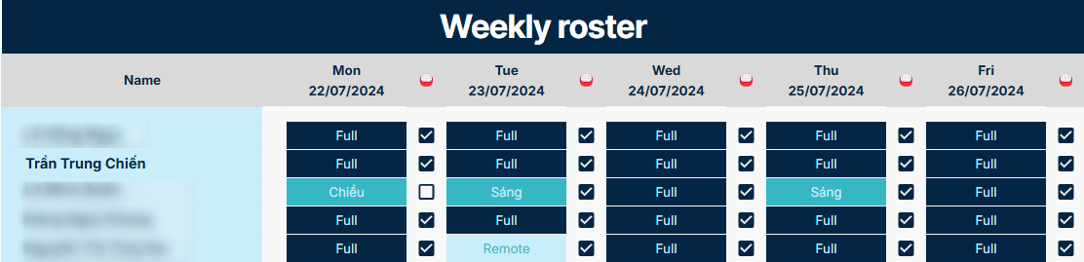

* *This demonstrates my timekeeping schedule for a specific week.*

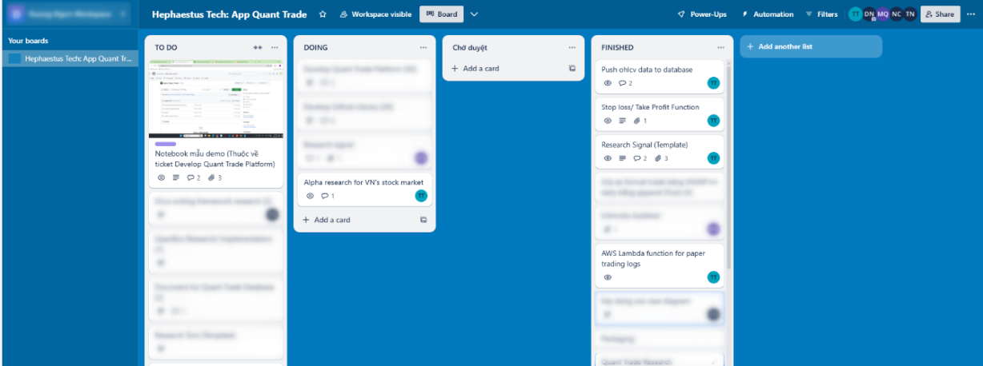

* *This demonstrates my tasks and the progress I’ve made on each one.*

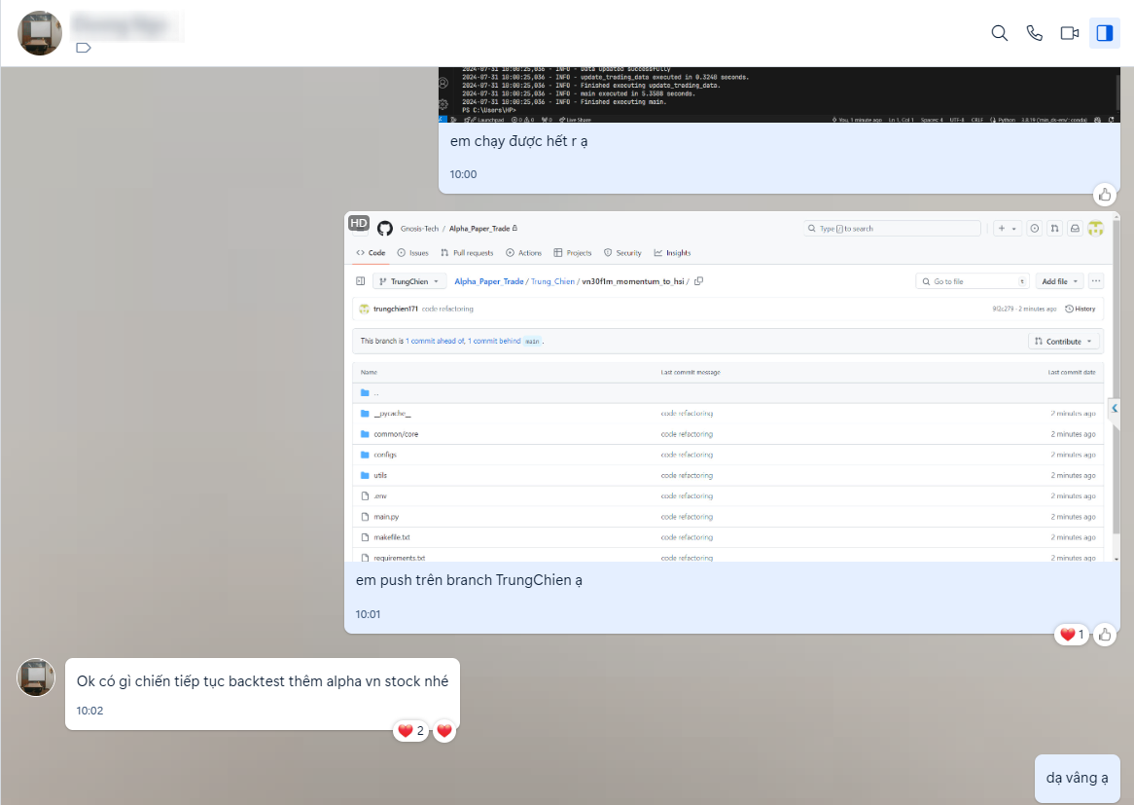

* *This illustrates my log chat with my quant research supervisor.*

**Appendix B: My Python code snippet for assessing VN30F1M historical OHLCV and its output.**

* *The data frame presents historical minute-by-minute trading data for the VN30F1M*

* Python code snippet for querying VN30F1M historical data from database.

**Appendix C: Time Series Analysis**

**Appendix D: Statistical Analysis**

* *VN30F1M follows Brownian motion.*

**Appendix E: My Python code snippet to demonstrate my trading strategy**

The function momentum (df, ticker) calculates the momentum of a specified ticker by comparing the current price with the price two days prior. It assigns a position value (1 for buy, -1 for sell, 0 for hold) based on this comparison and returns the DataFrame with the calculated positions.

**Appendix F: My Python code snippet for calculating alpha’s performance.**

The provided code defines a function backtest_price(price_series, position_series) that performs a backtest on a given price series based on a corresponding position series. It calculates the returns by taking the difference of the price series (price_series.diff()) and multiplying it by the shifted position series (position_series.shift()). This result is stored in a DataFrame bt. Additionally, it extracts the date from the index of bt and assigns it to a new column 'date'. The function is designed to return two metrics, sharpe and max_dd, which are likely calculated in the blurred portion of the code. These metrics typically represent the Sharpe ratio and maximum drawdown, key performance indicators in financial backtesting.

**Appendix G: My automated Telegram bot to push message of the paper trade’s info.**

*Orders are placed daily at 14:00. On some days, delayed messages were caused by my internet connection.*